REPORT

COURSE: CSE - 206

EXPERIMENT NO: 4

TOPIC: Comparator, Adder/ Subtractor

SUBMITTED BY:

1805021 - Abdus Samee

1805022 - Md. Tamimul Ehsan

1805023 - Mohammad Abrarul Hasanat

1805024 - Zannatul Naim

1805025 - Md. Fahim Shahriar

**Problem - 1**

Problem Specification:

Design using basic gates, a 2-bit comparator to compare 2-bit numbers X and Y. The circuit should provide 3 output lines to indicate X>Y, X=Y, and X<Y.

Required Instruments:

(1) 4 input pins, (2) 3 output pins, (3) 1 IC7404 gate, (4) 4 IC7408 gates, (5) 2 IC7432 gates, (6) Wires.

Truth Table;

|  |  |  |  |  |  |  |
| --- | --- | --- | --- | --- | --- | --- |
|  | X |  | Y |  | Output |  |
| P | Q | R | S | A(X<Y) | B(X=Y) | C(X>Y) |
| 0 | 0 | 0 | 0 | 0 | 1 | 0 |
| 0 | 0 | 0 | 1 | 1 | 0 | 0 |
| 0 | 0 | 1 | 0 | 1 | 0 | 0 |
| 0 | 0 | 1 | 1 | 1 | 0 | 0 |
| 0 | 1 | 0 | 0 | 0 | 0 | 1 |
| 0 | 1 | 0 | 1 | 0 | 1 | 0 |
| 0 | 1 | 1 | 0 | 1 | 0 | 0 |
| 0 | 1 | 1 | 1 | 1 | 0 | 0 |
| 1 | 0 | 0 | 0 | 0 | 0 | 1 |
| 1 | 0 | 0 | 1 | 0 | 0 | 1 |
| 1 | 0 | 1 | 0 | 0 | 1 | 0 |
| 1 | 0 | 1 | 1 | 1 | 0 | 0 |
| 1 | 1 | 0 | 0 | 0 | 0 | 1 |
| 1 | 1 | 0 | 1 | 0 | 0 | 1 |
| 1 | 1 | 1 | 0 | 0 | 0 | 1 |
| 1 | 1 | 1 | 1 | 0 | 1 | 0 |

Minimized equation:

For A(X<Y), we construct the K-map below:

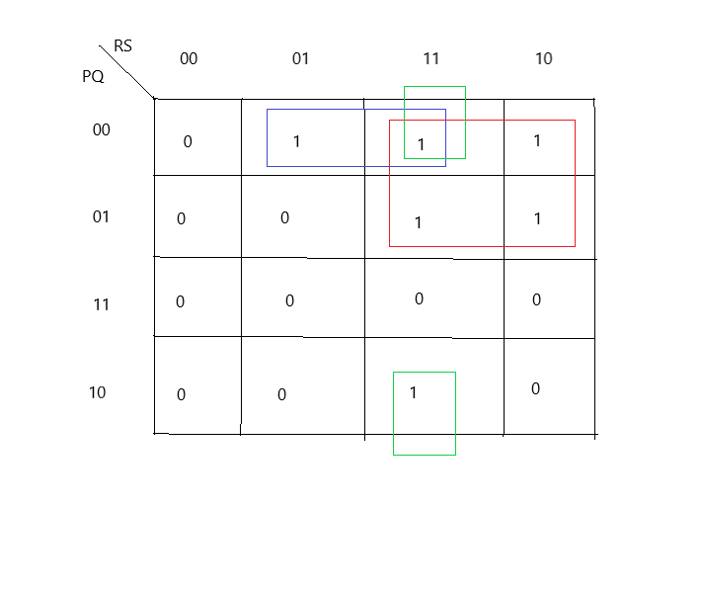

The simplified equation we get from the K-map is: P’R + Q’RS + P’Q’S

For B(X=Y), we construct the K-map below:

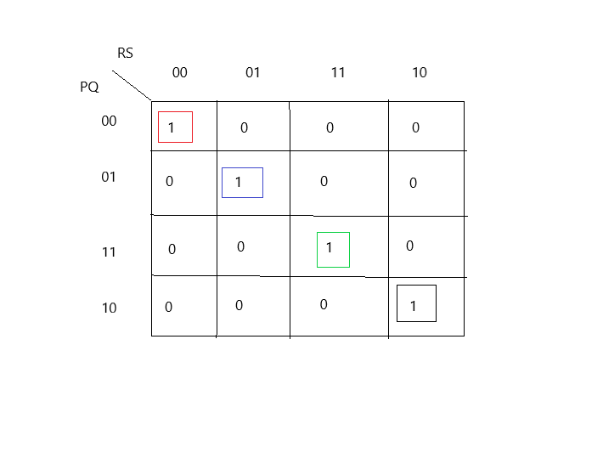

The simplified equation we get from K-map is:

P’Q’R’S’ + P’QR’S + PQRS + PQ’RS’

= P’R’(Q’S’ + QS) + PR (Q’S’ + QS)

= (PR + P’R’) (QS + Q’S’)

= (P⊙R) (Q⊙S)

For C(X>Y), we construct the K-map below:

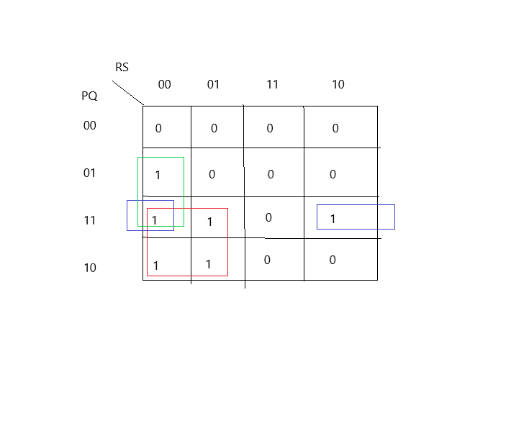

The simplified equation we get from K-map is:

PR’ + QR’S’ + PQS’

Circuit Diagram:

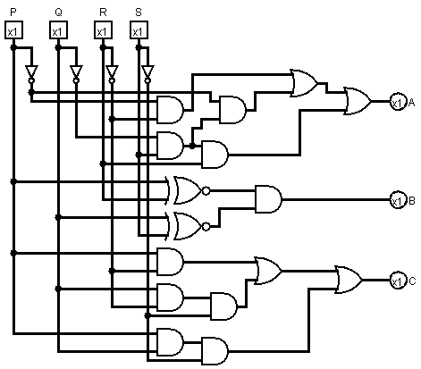

**Problem - 2**

Problem Specification:

Design a 1-bit full subtractor circuit using basic logic gates. Inputs are P, Q, and R denoting minuend, subtrahend, and previous borrow respectively. The outputs are D and B representing the difference and output borrow.

Required Instruments:

(1) 3 input pins, (2) 2 output pins, (3) IC7404 gate, (4) IC7408 gate, (5) IC7432 gate, (6) Wires.

Truth Table:

|  |  |  |  |  |
| --- | --- | --- | --- | --- |
| P | Q | R | D | B |
| 0 | 0 | 0 | 0 | 0 |
| 0 | 0 | 1 | 1 | 1 |
| 0 | 1 | 0 | 1 | 1 |
| 0 | 1 | 1 | 0 | 1 |
| 1 | 0 | 0 | 1 | 0 |
| 1 | 0 | 1 | 0 | 0 |
| 1 | 1 | 0 | 0 | 0 |
| 1 | 1 | 1 | 1 | 1 |

Minimized equation:

For D, we draw the K-map below:

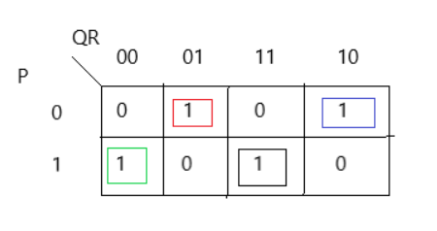

The simplified equation we get from the above K-map is:

D = P’Q’R + P’QR’ + PQ’R’ + PQR

or, D = P’(Q’R + QR’) + P(QR + Q’R’)

or, D = P’(Q⊕R) + P(Q⊙R)

or, D = P⊕Q⊕R

For B, we draw the K-map below:

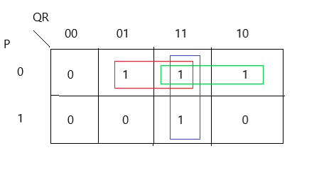

The simplified equation we get from the above K-map is:

B = P’R + QR + P’Q

Circuit Diagram:

